Love
Is it a feeling, an accident or a process?

Spring is the time of year when a young man’s fancy turns to what women have been thinking about all year long.
What is love? Some people will tell you that it is a chemical reaction where certain hormones are released into the body. Something equally unhelpful was told to me by my grandfather, “Love is something like a lizard, it worms its way into your heart and nibbles at your gizzard.” Neither of these statements answer the what, when, and how of love.
Many people confuse love and sex. “If we are having sex, we must be in love.” “Well, if we are in love, then is it okay to have sex?
Sex is something you can add to love, or you can be in love with someone and choose not to have sex.
Some people talk about love as an accident. “I fell in love!” Was it like slipping on a banana peel? If you can fall into love, then it certainly makes sense that you can fall out of love. The feelings of love are a guarantee of nothing. The beautiful thing about love is that since it is a step-by-step process, if you should fall out of love, you can simply go through the process again and “fall in love” again.
The What of Love: Love is a process. If you go through the steps in the process, you will feel the feelings of love. The love feelings are not limited by gender. It can be between a male and a female. It can be between a male and a male. It can be between a female and a female. It can be between you and God.
The First Step in the Love Process. This process is to make the decision to get to know some person. You cannot be in love with somebody you have never met! The concept of love at first sight is a fallacy. You may have lust at first sight, but as you continue the steps, you may reach the feelings of love.
The Second Step in the Love Process. This step is where you spend time with that person. Spending time with someone doesn’t mean you’re just in the same room on the same couch watching the same TV program. That is not spending time together.
Spending time with someone requires that you share about you and listen to and accept the other person when they share back. This is about getting to know the other person.

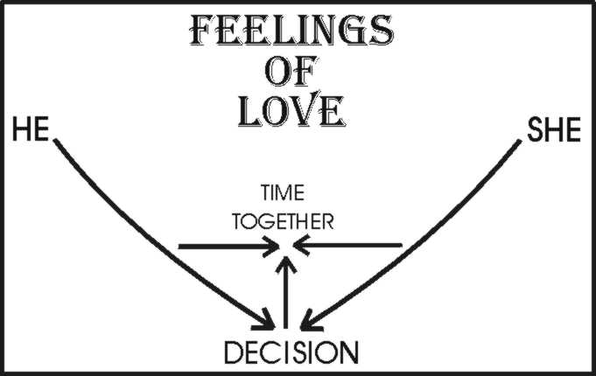
Most people start this process by “putting their best foot forward.” But, this requires that, at some point, you bring up the other foot! This is where the third step comes in.
The Third Step in the Love Process. This requires that you are open and honest with each other, down to your very core. Honesty comes in degrees. With some people, you are more honest than with other people.
Level 1 Honesty. I see honesty as a yellow onion. Start with the outside which is very thin and there isn’t much to it. This level of sharing you would do with anyone, including a stranger. “Good morning. How are you today?”
Level 2 Honesty. The next level of the onion you would share with fewer people. This level is a historical report of what happened the day before, the week before, or five years before. “It was a wild party. When the cops came, grandma ran out the back door.”
Level 3 Honesty. Going to the next level of the “onion” is where you share personal, but non-blackmailable information. This kind of information you reserve for your more intimate relationships. “My uncle Joe, by marriage, had a bad drinking problem and ended up in the mental hospital.” “When we were children, my sister used to use me as a punching bag.”
Level 4 Honesty. The final level of sharing is where you are willing to risk sharing personal and blackmailable information. This is information that can be brought up and used against you in a fight. “When we were children, I used my sister as a punching bag.” “My ex-girlfriend said I was a terrible lover.” Or, “I flunked out of college.” Or, “In my first marriage, my ex said I was a cold fish.” Or, “I had a drug problem before I met you.”
When I talk about honesty, I’m talking about getting down to this level 4! Otherwise, you can always tell yourself “If he/she knew this about me, they wouldn’t love me.” Now, I am not suggesting that you go to Level 4 on your first date. But, if you go past a month and have not shared to Level 4, then you will find it harder and harder to be honest with this person.
THE FOURTH STEP in the LOVE PROCESS is perhaps the hardest. After you have shared to your very core, and they have shared to their very core, then to accept the other person for who they really are and to do it with compassion and without any judgment, expressed or unexpressed, is the true expression of love.
Acceptance does not mean approval. This is a problem that many people have with acceptance. Acceptance means to accept someone where they are now with all their blemishes, faults and shortcomings. If someone is living a self-destructing lifestyle, do you still need to accept them? Yes! This is about accepting the person, not accepting their behaviors that are destructive. This is about accepting the “isness” (the reality) of what the person is doing. “I love and accept you, but I see you doing behaviors that can kill you, and that makes me very sad and angry at you, because I do not want to lose you. If you end up dying, I will be very sad because you will have missed out on the wonderful life that you could have.” It is very important to be able to express both your love and acceptance. This sometimes is the only hope that the person may have.
The test of love is to ask the ones you love, mate, children, parents, “Do you love me?” If they say yes, then ask the harder second question, “Do you accept me?” Can you love someone without accepting them? The answer is yes, BUT. . .. “Yes, I know that you love me. I see all the things you do for me. But, I don’t feel accepted by you.” You will find little passion in relationships where there is love but no acceptance!
If you are willing to go through each one of these steps, then you will experience the feelings of love!
Love is both a feeling and a process. If you go through the process of love, you will end up with the feelings of love. However, love is a guarantee of nothing! How many people do you know that have been in love with each other, got married, and years later say, “We have fallen out of love, so were getting a divorce?”
There is a guarantee that once you have gone through the love process, that you can keep your feelings of love going for the rest of your life! When you have reached the feelings of love, all you have to do is to do it all over again. The beautiful thing about the love process is in order to continue to produce loving feelings, go back and do each one of these steps again.
Look at the diagram below. Since love is a process, you can continue that process on a regular basis for the rest of your life together.
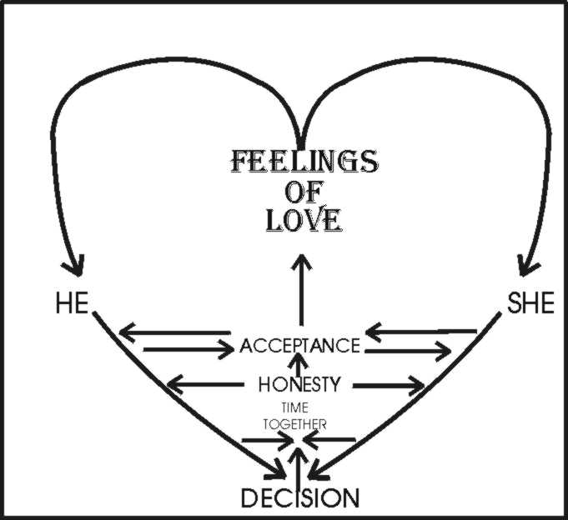
The decision is yours! Love is not an accident. Love is not animal magnetism. Love is a step-by-step process that you can repeat daily, weekly or you can allow your love relationship to die the death of neglect. The decision is yours and your mates. How much time are you willing to invest in keeping your feelings of love going?
Myron Doc Downing PhD
Specializing in Relationships, Depression,
Anger Management & Anxiety Disorders.
Email: DocDowning103@gmail.com
Website: DocDPhD.com

